FootFusion

Use-Case Specification: Manage Information

Version 1.0

Revision History
Date | Version | Description | Author
26/11/2024 | 1.0 | Complete the final draft | Vu Thi Anh Thu

Table of Contents
1. Use-Case Name 2
1.1 Brief Description 2
2. Flow of Events 2
2.1 Basic Flow 2
2.2 Alternative Flows 2
2.2.1 < First Alternative Flow > 2
2.2.2 < Second Alternative Flow > 2
3. Special Requirements 2
3.1 < First Special Requirement > 2
4. Preconditions 2
4.1 < Precondition One > 2
5. Postconditions 2
5.1 < Postcondition One > 2
6. Extension Points 2
6.1 <Name of Extension Point> 2

Use-Case Specification: Manage Information

Manage Information

Brief Description
The "Manage Information" use case allows Admin users to update and maintain the content displayed on the homepage. This includes editing body content and email sign-up field. The purpose of this use case is to provide Admin with an intuitive and efficient way to keep the homepage content fresh, relevant, and aligned with the business goals. By enabling easy management of homepage elements, this use case helps improve the overall user experience, increase engagement, and enhance the visual appeal and branding of the system..

Flow of Events

Basic Flow
After logging in, the Admin is directed to the homepage, where a navigation bar is located at the top of the page. This bar includes the logo and functional buttons arranged from left to right: Home, Product, Blog, Search icon, Favorite List icon, Shopping Cart icon, and Admin Account icon.
Beneath the navigation bar, the main body of the page displays an "About Us" section, with an edit icon allowing the Admin to modify the content, such as images and text. There is also a text field where users can enter their email address, accompanied by a "Join Now" button. At the bottom of the section, the Admin can click the "Save Changes" button to save any updates made to the content. Upon saving, a notification pop-up will appear to confirm the changes were successfully saved.

Alternative Flows
None.

Special Requirements
None.

Preconditions

User Authentication
Admins must be logged into the admin account with valid credentials (username and password) to access and manage information.

Postconditions

Updated Content
The information has been updated in the system and is now visible to both the shop owner and customers on the Internet..

Confirmation to Admin
Admin receives a confirmation message or notification indicating that information has been successfully updated.

Extension Points
None.

Prototype
After logging in, the Admin is directed to the homepage, where a navigation bar is located at the top of the page.
Beneath the navigation bar, the main body of the page displays an "About Us" section, with an edit icon allowing the Admin to modify the content, such as images and text. There is also a text field where users can enter their email address, accompanied by a "Join Now" button. At the bottom of the section, the Admin can click the "Save Changes" button to save any updates made to the content.
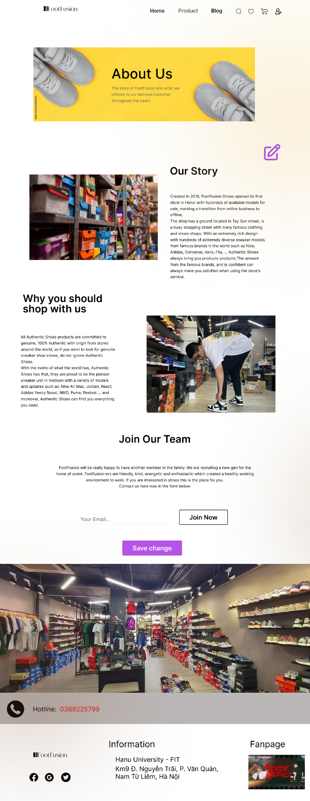
Upon saving, a notification pop-up will appear to confirm the changes were successfully saved.
